**Practical No. 02**

**Control Structures in PL/SQL**

**Name: Sibaraj Lenka**

**Class:FYBScIT(A)**

**Roll No.:58**

**Subject: Procedural Language extensions**

**to the Structured Query Language**

**Sign:**

**A. Do loop**

DECLARE

counter NUMBER := 1;

BEGIN

LOOP

DBMS_OUTPUT.PUT_LINE('Counter value: ' || counter);

counter := counter + 1;

EXIT WHEN counter > 5;

END LOOP;

END;

/

**Output:**

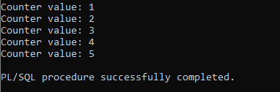

**B. While-Loop Statements**

DECLARE

a number(2) := 10;

BEGIN

WHILE a < 20 LOOP

dbms_output.put_line('value of a: ' || a);

a := a + 1;

END LOOP;

END;

/

**Output:**

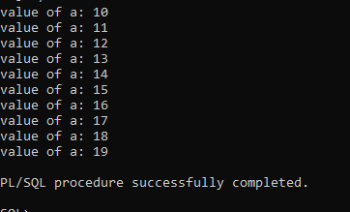

**C. For-Loop Statements**

CODE:

DECLARE

a number(2);

BEGIN

FOR a in 10 .. 20 LOOP

dbms_output.put_line('value of a: ' || a);

END LOOP;

END;

/

**Output:**

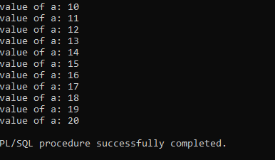

**D. GoTO Statements**

DECLARE

a number(2) := 10;

BEGIN

<<loopstart>>

-- while loop execution

WHILE a < 20 LOOP

dbms_output.put_line ('value of a: ' || a);

a := a + 1;

IF a = 15 THEN

a := a + 1;

GOTO loopstart;

END IF;

END LOOP;

END;

/

**Output:**

